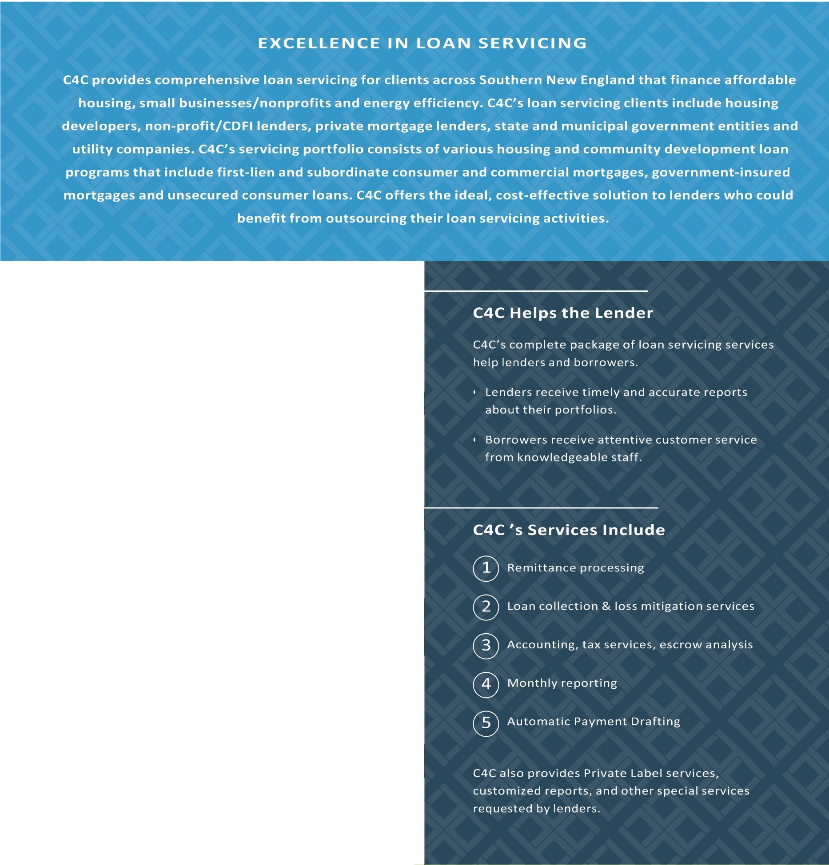

Carith Dean
Director, Loan Servicing
Company : NMLS#276717
P 860 .233 .5165 ext. 2017
E cdean@capitalforchange.org


CAPITAL
FOR
CHANGE
C4C services a portfolio valued at over $200 million
whose clients include:
0
0
®
@
The Connecticut Housing Finance Authority
Habitat for Humanity
State of Connecticut
Various other municipalities around the State of CT
C4C Focuses on Customer Service:
C4C specializes in providing services that meet the needs of affordable housing lenders by providing a high level of customer service to first-time and community
development borrowers.
Contact Us Today!












Who is Capital For Change, Inc.?
Capital For Change, Inc. (C4C), is the largest full-service Community Development Financial Institution (CDFI) in Connecticut. We serve
people, nonprofits, small business and public institutions by providing flexible, creative and responsive financial products and services that support an inclusive and sustainable economy. Our high impact programs and products broaden access to affordable housing, energy efficiency and job opportunities for underserved communities and the families that live there.
Who are C4C’s Loan Servicing Clients?
C4C’s loan servicing clients are state, federal, private mortgage, and CDFI lenders. C4C’s portfolio consists of fifty different housing
and community development loan programs. Clients include the Connecticut Housing Finance Authority (CHFA), the Connecticut Department of Economic and Community Development (DECD), various Habitat for Humanity, and the Connecticut CDFI Alliance.
Why Use C4C for your Loan Servicing Needs?
C4C offers the ideal solution to lenders who want to outsource their loan servicing activities. C4C provides superior customer service to both
borrowers and mortgagees. C4C can customize monthly report data and provide information to clients in real time. C4C offers many features for its customers, including automatic payment deduction to borrowers, a website where borrowers can make online payments, and easy- to–read year-end statements.
What are C4C’s Fees for its Loan Servicing Services?
C4C generally charges a fee ranging from $8.00 to $16.00 per loan per month. The price per loan per month varies depending on the size
of the portfolio serviced and the selection of services C4C provides to the lender. C4C also charges a one-time fee to transfer and set up an existing portfolio on C4C’s software and inform borrowers of a change in servicer.
Capital for Change
10 Alexander Drive
Wallingford, CT 06492
P. 860-233-5165 T. 800-992-3665

